MODULE 4

1. Plot a Bar Chart to demonstrate the total number of **upper** and **lower division** courses.

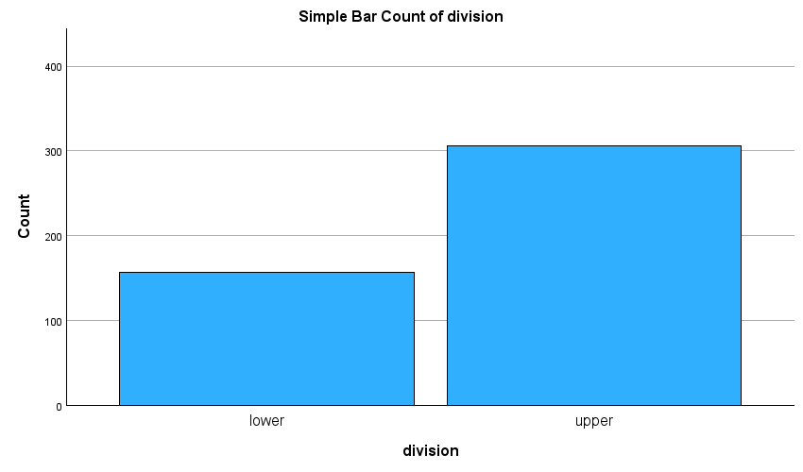

**2.**Reproduce the chart as requested above in 1 and differentiate by **credits**.

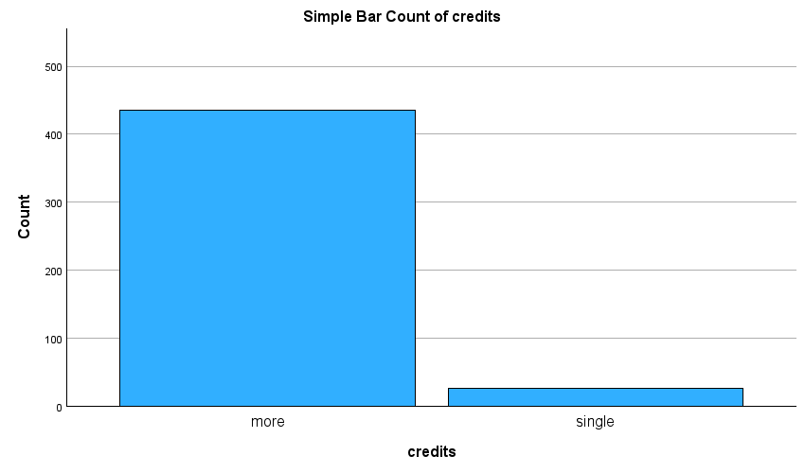

**3.**Reproduce the chart as requested above in 1 and further differentiate by **tenure**.

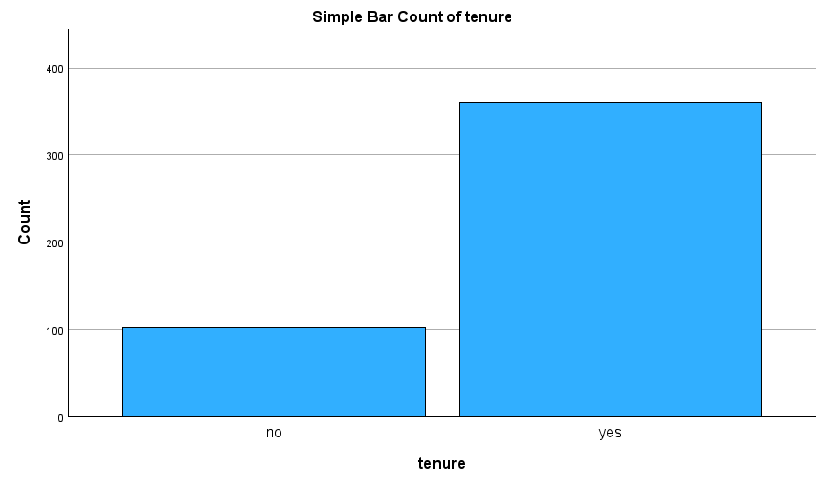

**4.**Using Bar Chart, plot the average beauty scores differentiated by **tenure** and **native**.

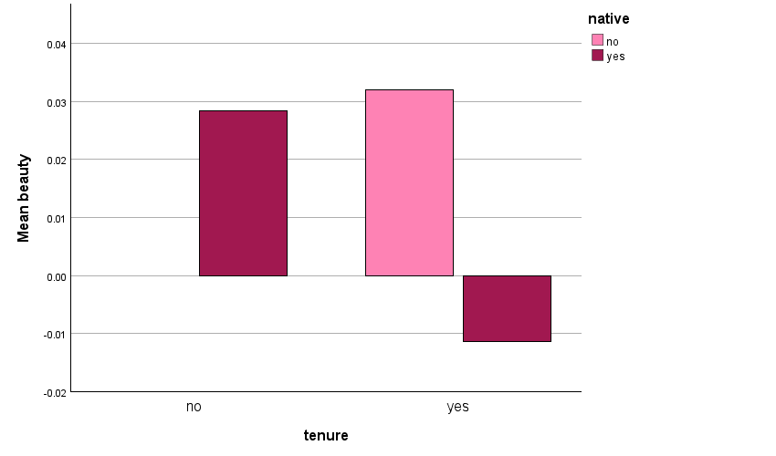

**5.**Using a Scatter Plot, demonstrate the relationship between **age** and **students**.

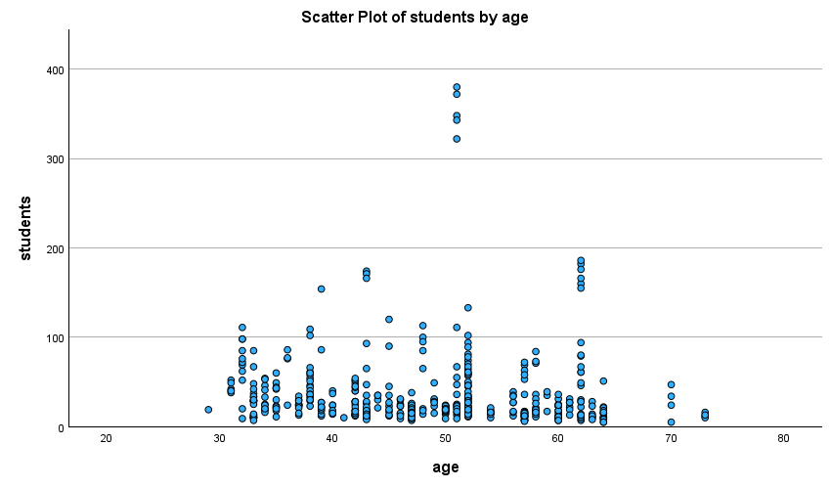

**6.**Plot a Histogram for age differentiated by **tenure**.

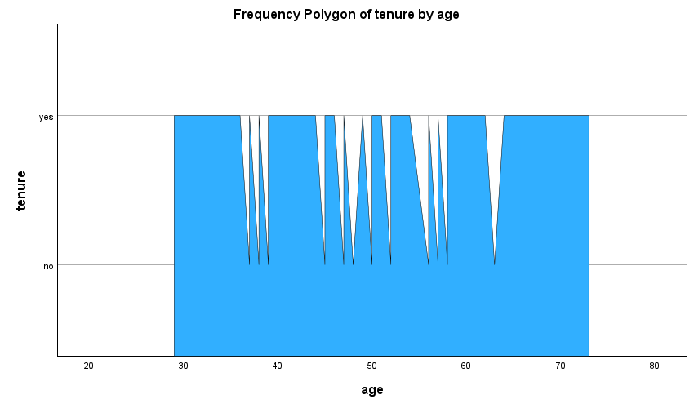

**7.**Create a Box Plot for age differentiated by **vismin**.

